|  |  |  |  |  |  |  |  |
| --- | --- | --- | --- | --- | --- | --- | --- |
| **Date:** | **27-05-20** | | | | **Name:** | **TANOJ M** | |
| **Sem & Sec** | **VI A** | | | | **USN:** | **4AL16CS113** | |
| **Online Test Summary** | | | | | | | |
| **Subject** | | **SSCD 2 IA Test** | | | | | |
| **Max. Marks** | | **30** | | **Score** | | **21** | |
| **Certification Course Summary** | | | | | | | |
| **Course** | **Front end development in HTML** | | | | | | |
| **Coding Challenges**  1)write a c program to sort an array of integers in ascending order and display the sorted array and number of passes performed for sorting | | | | | | | |
| **Certificate Provider** | | | **Great learning** | **Duration** | | | **6DAYS** |
| **Status:Completed** | | | | | | | |
| **Uploaded the report in Github** | | | | **Yes** | | | |
| **If yes Repository name** | | | | https://github.com/Tanoj8296/DAILY-STATUS | | | | |
|  | | | | |
| **Uploaded the report in slack** | | | | **Yes** | | | |

**DAILY ONLINE ACTIVITIES SUMMARY**

**Ce Certification Details**

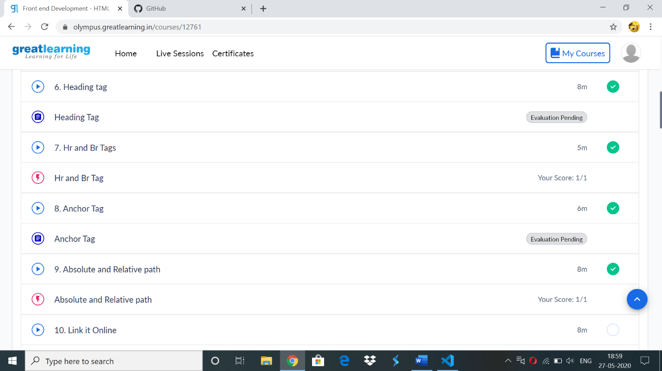

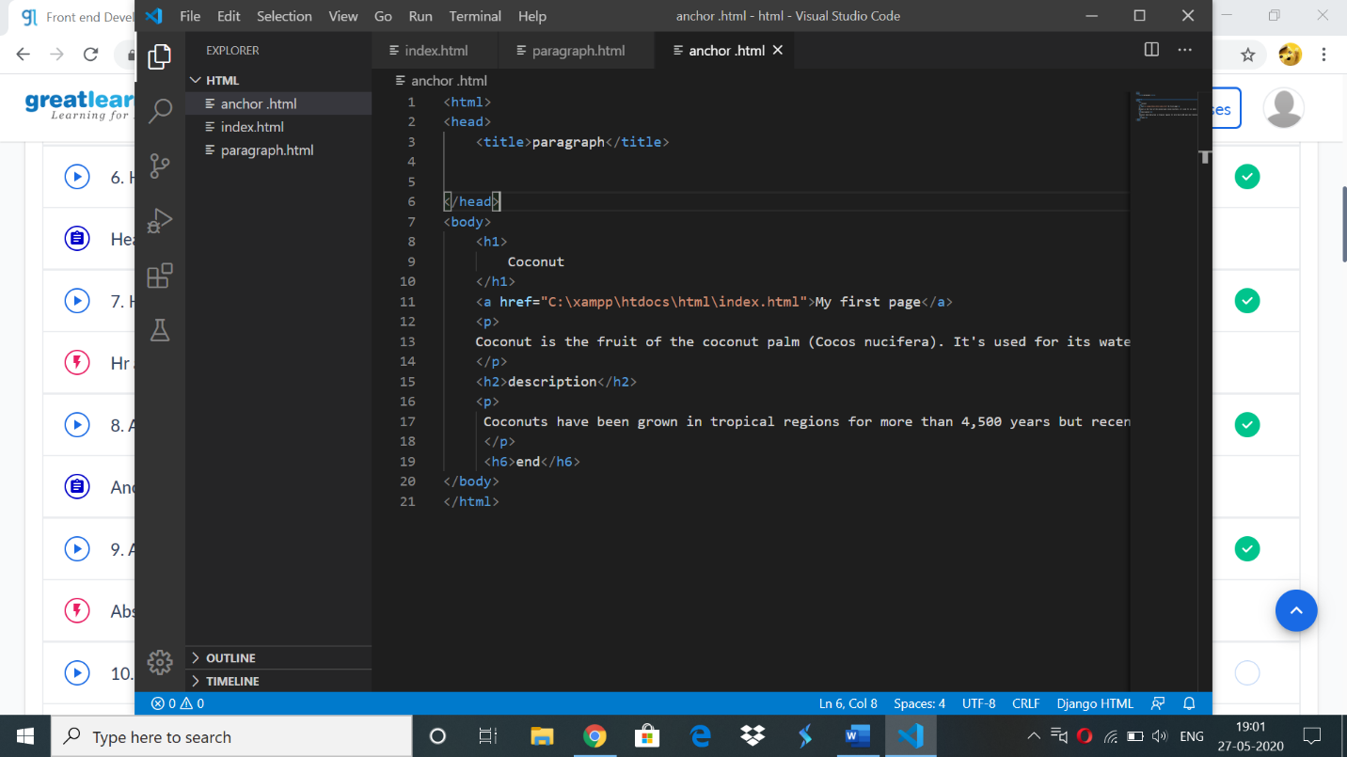

Online codding challenge:

#define MAXSIZE 10

void main()

{

int array[MAXSIZE];

int i, j, num, temp,c=0;

printf("Enter the value of num \n");

scanf("%d", &num);

printf("Enter the array elements \n");

for (i = 0; i < num; i++)

{

scanf("%d", &array[i]);

}

for (i = 0; i < num; i++)

{

for (j = 0; j < (num - i - 1); j++)

{

if (array[j] > array[j + 1])

{

temp = array[j];

array[j] = array[j + 1];

array[j + 1] = temp;

c++;

}

}

}

printf("Sorted array is...\n");

for (i = 0; i < num; i++)

{

printf("%d\n", array[i]);

}

printf("Num of iteration %d",c);

}

**OUTPUT**

